CS-468: Software Quality Assurance & Testing
White-Box Testing — SIMPLE REVISION NOTES
Week 10 & Week 11 — short, simple, easy to memorize

1. Why White-Box Testing?
- Looks INSIDE the code, not just the spec.
- Does 2 jobs: (1) measures coverage of tests you already have, (2) designs NEW tests to fill the gaps.
REMEMBER IT AS: Test → Measure → Fill the gaps.

2. Test Coverage — The Basic Idea
Coverage = (Items exercised ÷ Total items) × 100%
- “Item” = whatever you're counting (statements, decisions, etc.)
⚠ 100% Coverage ≠ 100% Tested
- Only measures ONE angle — same coverage, different tests can still catch different bugs.
- Only sees code that EXISTS. Can't catch missing features.
- Missing spec item → caught by specification-based testing.
- Missing from spec entirely → maybe caught by experience-based testing.
REMEMBER IT AS: Coverage checks what's THERE — never what's MISSING.

3. Statement Coverage
Statement Coverage = (Statements run ÷ Total statements) × 100%
- Just checks: did this LINE execute? Yes/No.
Example (quick):
IF A > B THEN C=0 ENDIF → 1 test with A>B (e.g. A=12, B=10) = 100% statement coverage.
A | B | C | Lines Hit | Coverage
2 | 3 | 8 | 1,2,3,4,6 | 83%
0 | 25 | 50 | 1,2,3,4,6 | 83%
47 | 1 | 49 | 1,2,3,4,6 | 83%
20 | 25 | 70 | 1,2,3,4,5,6 | 100%

REMEMBER IT AS: You need ONE test that makes the IF TRUE to touch every line.

4. Decision Coverage
- Decision = IF / loop / CASE — anywhere with 2+ possible outcomes.
Decision Coverage = (Outcomes exercised ÷ Total outcomes) × 100%
Example (quick):
- Test 1: A=20, B=15 → C=−10 → TRUE branch only.
- Add Test 2: A=10, B=2 → C=6 → FALSE branch.
- Together = both branches covered = 100% decision coverage.
⭐ GOLDEN RULE: 100% Decision Coverage → always gives 100% Statement Coverage.
100% Statement Coverage → does NOT always give 100% Decision Coverage.
REMEMBER IT AS: Decision Coverage = the harder exam. Statement Coverage = the easy quiz. Passing the hard exam auto-passes the easy one — not the other way round.

5. Loops — While / Do-While / For
Loop | Check Condition | Body Guaranteed?
WHILE / FOR | Before body runs | No (may run 0 times)
DO-WHILE | After body runs | Yes (always ≥ 1 time)

REMEMBER IT AS: WHILE/FOR = look before you loop. DO-WHILE = leap first, look after.

6. Case Study — Gold Card / Airline Upgrade
Passenger with a gold card → may skip straight to upgrade. No gold card + full economy + late check-in → may get bumped. 10 numbered boxes, 4 decision points (boxes 1, 2, 6, 8).
(a) 5 Tests = Maximum Decision Coverage
Card | Business Class | Economy | Path
Gold | Not Full | Don't Care | 1,2,4,5
Gold | Full | Not Full | 1,2,3,5
Not Gold | Don't Care | Not Full | 1,6,7,5
Not Gold | Not Full | Full | 1,6,8,9,5
Not Gold | Full | Full | 1,6,8,10

(b) 3 Tests → Statement Coverage Check
- Test 1: Gold, upgraded → path 1,2,4,5 → 4/10 = 40%
- Test 2: Not gold, economy → path 1,6,7,5 → 4/10 = 40%
- Test 3: Bumped → path 1,6,8,10 → 4/10 = 40%
REMEMBER IT AS: 5 tests = full branch coverage. Any smaller set (like 3) gives partial coverage — always check paths against total statements (10).

7. Control Flow Graph (CFG)
- A flowchart's skeleton — shows ONLY decisions, skips plain lines.
- Node = decision point OR where a structure re-joins the main flow (e.g. ENDIF).
- Edge = line joining two nodes.
- Region = closed shape formed by nodes + edges.
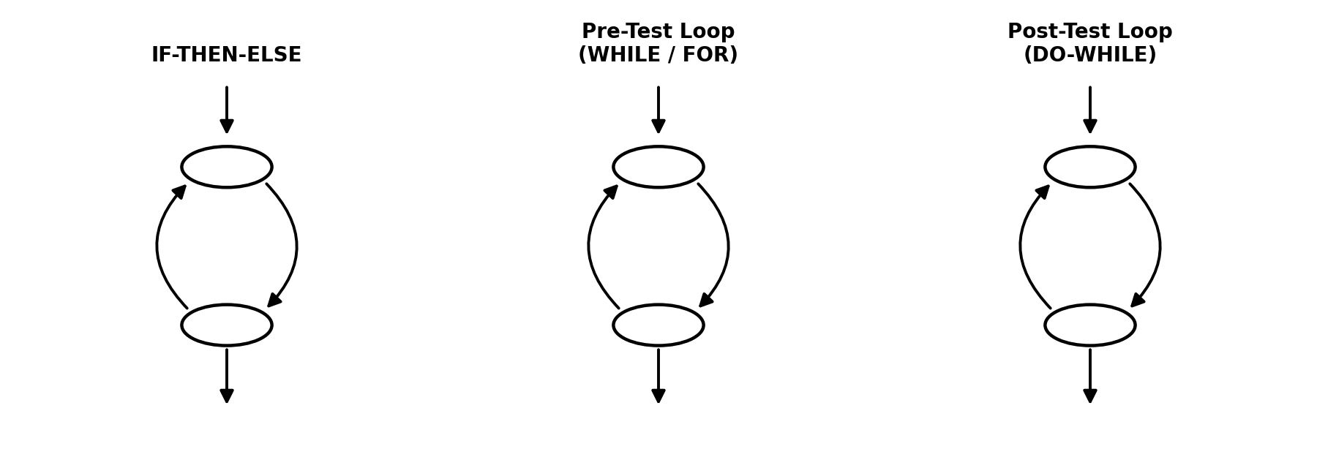
If-Then-Else | Pre-Test Loop (While/For) | Post-Test Loop (Do-While)
- If-Then-Else: splits into 2 branches, then rejoins.
- Pre-test loop: check FIRST, may skip body entirely.
- Post-test loop: run body FIRST, check after.
REMEMBER IT AS: Any code = built from just these 3 shapes.
3 Steps to Draw a CFG:
- Find every decision (ignore plain lines).
- Add 1 node per decision.
- Expand each node with its matching subgraph shape.
Quick Example — MaxAndMean
Nested IFs: IF A>B → (IF A>C) else (IF B>C) → both merge into one ENDIF.
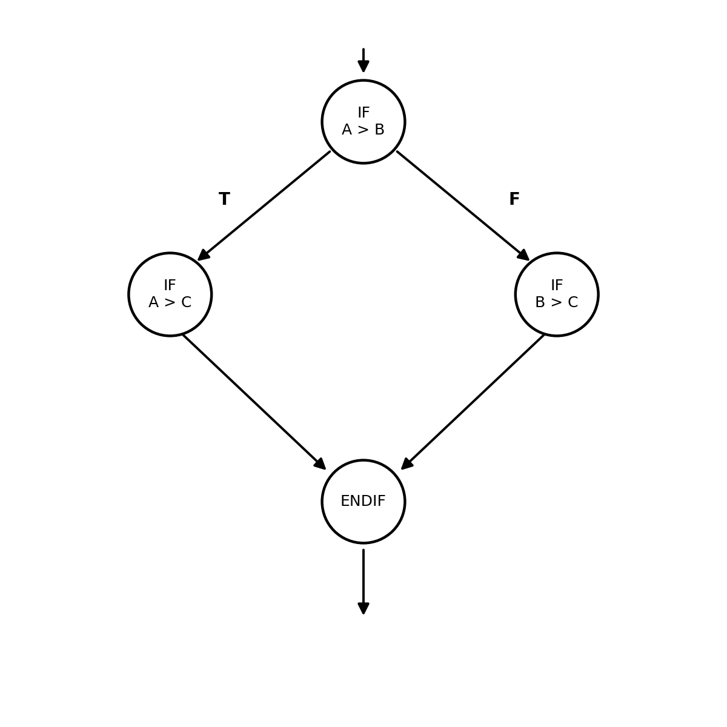
Both nested IFs converge on the same ENDIF.

8. Hybrid Flow Graph
- = CFG + a letter on every edge.
- A path through the code becomes a simple code, e.g. 'abeh'.
REMEMBER IT AS: Think of it as a treasure map with lettered roads — a path is just the sequence of letters you walk through.
Quick Example — BestInterest
Balance > 1000 branches into 2 real paths: Balance 1,000–10,000 (path 'abcegh') and Balance > 10,000 (path 'abdfgh').
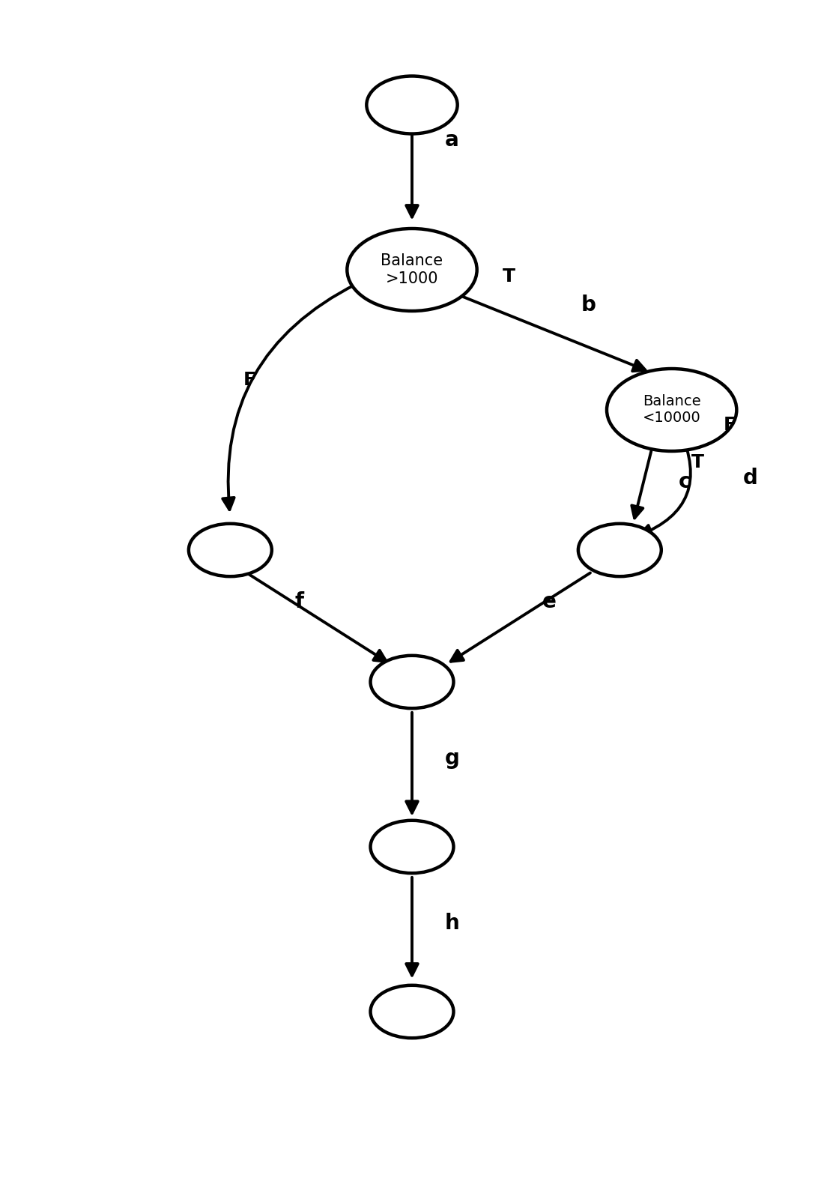
Paths 'abcegh' and 'abdfgh' — 2 tests give 100% statement coverage.
Answer: 2 tests (e.g. Balance=£5,000 and Balance=£20,000) = 100% statement coverage.

9. Same Case Study → CFG + Hybrid Version
- 4 decision diamonds (gold card?, business class full? ×2, economy full?) → 4 CFG nodes.
- Each node = if-then-else shape → True/False edges rejoin at their own ENDIF.
- Label every edge with a letter for the hybrid version → name any test's path, just like 'abcegh'.

10. Formula Cheat Sheet
Coverage = (items exercised ÷ total items) × 100%
Statement Coverage = (statements run ÷ total statements) × 100%
Decision Coverage = (outcomes run ÷ total outcomes) × 100%

11. Exam Questions — Quick Answers
- Tests for 100% decision coverage? → Cover every True AND False at every decision point.
- Tests for 100% statement coverage? → Fewer needed — just touch every line at least once.
- Coverage from ONE input? → Trace it, list lines/branches hit, apply formula.
- Generate data for max statement coverage? → Smallest set of inputs touching every line.
- Generate data for max decision coverage? → Every branch driven True once AND False once.

12. ⚡ One-Page Cheat Sheet (Last-Minute Recall)
Term | Remember it as
Test Coverage | items exercised ÷ total items × 100
Statement Coverage | Did the LINE run?
Decision Coverage | Did BOTH branches (T/F) run?
100% Coverage | ≠ 100% tested — only shows what's THERE
Decision vs Statement | 100% Decision → 100% Statement (not reverse)
WHILE / FOR | check first — may run 0 times
DO-WHILE | run first, check after — always ≥ 1
CFG Node | decision point / re-join point
CFG Edge | line joining 2 nodes
CFG Region | closed area of nodes+edges
Hybrid Flow Graph | CFG + lettered edges = named paths
Gold Card Case Study | 10 statements, 4 decisions, 5 tests = max coverage

